METHODS OF INSTRUMENTAL ANALYSIS

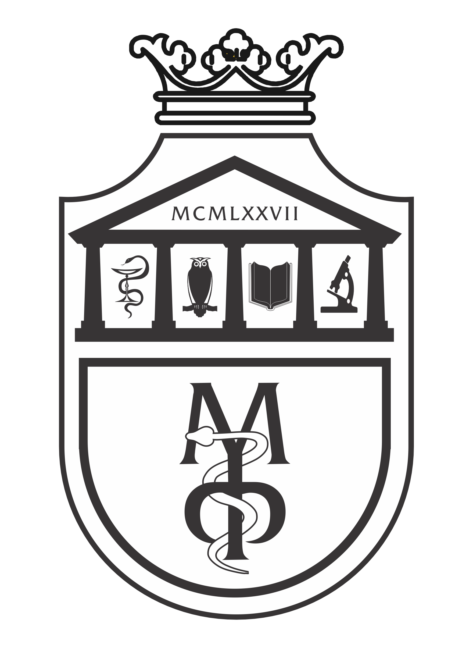

Pharmacy - Integrated academic studies

SECOND YEAR- Semester IV

2025/2026.

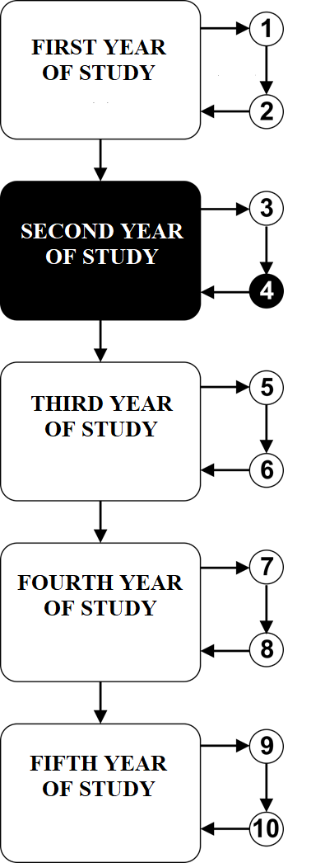

Subject:

METHODS OF INSTRUMENTAL ANALYSIS

The course is evaluated with 5 ECTS. There are 4 hours of active classes per week (2 hours of lectures and 2 hours of practice)

TEACHERS AND ASSOCIATES:

 | Name and surname | E-mail address | Academic rank
1. | Nedeljko Manojlović | mtnedeljko@yahoo.com | Full professor
2. | Jovica Tomović | jovicatomovic2011@gmail.com | Assistant professor
3. | Aleksandar Kočović | salekkg91@gmail.com | Assistant professor

Course structure:
Module | Name of the module | Weeks | Lectures | Practice | Module Coordinator
1 | Principles and division of instrumental methods. Atomic absorption spectrophotometry, flame photometry, refractometry, polarimetry and colorimetry. Electrochemical methods. Potentiometry. pH-metry. Analysis of secondary metabolites. | 5 | 2 | 2 | Full prof. Nedeljko Manojlović
2 | Instrumental chromatographic methods of analysis. Gas and liquid chromatography. Combined methods. NMR spectroscopy. | 5 | 2 | 2 | Full prof. Nedeljko Manojlović
3 | UV-VIS and IR spectroscopy. Mass spectrometry. Solving spectral problems (UV-VIS and IR spectroscopy, NMR and MS). | 5 | 2 | 2 | Full prof. Nedeljko Manojlović
Σ 30+30=60

Students' knowledge assessment:

The student masters the subject in modules. The grade is equivalent to the number of points earned (see tables). Points are earned in two ways:

EXAM PREREQUISITES: A student can earn a total of 30 points from three areas. A minimum of 16 points is required for a student to pass the prerequisites.
FINAL EXAM: A student can earn a maximum of 70 points in the final exam, which covers the entire course material (lectures, exercises, and spectral problems).

MODULE |  | MAXIMUM POINTS |  |  |  | MAXIMUM POINTS
 |  | Exam prerequisites | Exam |  | Σ
1 | Principles and division of instrumental methods. Atomic absorption spectrophotometry, flame photometry, refractometry, polarimetry and colorimetry. Electrochemical methods. Potentiometry. pH-metry. Analysis of secondary metabolites. | 10 | 70 | 100
2 | Instrumental chromatographic methods of analysis. Gas and liquid chromatography. Combined methods. NMR spectroscopy. | 10 | 70
3 | UV-VIS and IR spectroscopy. Mass spectrometry. Solving spectral problems (UV-VIS and IR spectroscopy, NMR and MS). | 10 | 70
Σ |  | 30 | 70 | 100

The final grade is formed as follows:

In order to pass the course, the student must obtain a minimum of 51 points. The final grade is formed on the basis of the number of points that can be gained on the following ways:
- Pre-exam activities - Pre-exam activities are assessed through testing of exercises and knowledge of the area covered by the material. In each of the pre-exam activities, the student must achieve more than 50 percent.
- Final exam - The student must achieve more than 50 percent (36 points) of the maximum 70 points. The final exam includes a knowledge check from the overall material covered during the class. It can also include solving spectral problems.

Num. achieved points | Num. grade | Definition
0 – 50 | 5 | UNSATISFACTORY
51 – 60 | 6 | PASS
61 – 70 | 7 | SATISFACTORY
71 – 80 | 8 | GOOD
81 – 90 | 9 | VERY GOOD
91 – 100 | 10 | EXCELLENT

LITERATURE:
Textbook | Authors | Publisher | Availability in the library
Pharmaceutical analysis: a textbook for pharmacy students and pharmaceutical chemists. | Watson DG. | Elsevier Health Sciences; 2015. | YES
Handbook of modern pharmaceutical analysis (Vol. 10). | Ahuja S. and Scypinski S. | Academic press; 2010. | YES
Pharmaceutical Analisys. | Lee D. | Oxford:Blackwell Scientific Publications. 2003. | YES
Ultraviolet and visible spetroscopy. | Thomas M. | New Jersay: John Willey and Sons. 1996. | YES
Atkins' Physical Chemistry, 11th Edition. | Atkins P, de Paula J, and Keeler J. | Oxford University Press. 2017. | YES

All lectures (powerpoint presentations) are available on the website of the Faculty of Medical science: www.medf.kg.ac.rs

PROGRAM

FIRST MODULE: PRINCIPLES AND DIVISION OF INSTRUMENTAL METHODS. ATOMIC ABSORPTION SPECTROPHOTOMETRY, FLAME PHOTOMETRY, REFRACTOMETRY, POLARIMETRY AND COLORIMETRY. ELECTROCHEMICAL METHODS. POTENTIOMETRY. pH-METRY. ANALYSIS OF SECONDARY METABOLITES.

UNIT I (FIRST WEEK):

Lectures (2 classes) | Practice (2 classes)
Principles and types of instrumental methods. Electromagnetic radiation. | Methods for determining the qualitative and quantitative composition of pharmaceutical substances. Application of the Lambert-Behr law.

UNIT II (SECOND WEEK):

Lectures (2 classes) | Practice (2 classes)
Qualitative and quantitative analysis. Lambert-Beer law. | Application of the Lambert-Beer law.

UNIT III (THIRD WEEK):

Lectures (2 classes) | Practice (2 classes)
Basics of refractometry, polarimetry and colorimetry. | Measurement on a refractometer, polarimeter and colorimeter.

UNIT IV (FOURTH WEEK):

Lectures (2 classes) | Practice (2 classes)
Electrochemical methods. | Measurement on a pH-meter. Emission and absorption methods. Atomic absorption spectrophotometry (AAS). Flame photometric analysis.

UNIT V (FIFTH WEEK):

Lectures (2 classes) | Practice (2 classes)
Analysis of natural products. | Methods of analysis of natural products.

INSTRUMENTAL CHROMATOGRAPHIC METHODS OF ANALYSIS. GAS AND LIQUID CHROMATOGRAPHY. COMBINED METHODS. NMR SPECTROSCOPY.

UNIT VI (SIXTH WEEK):

Lectures (2 classes) | Practice (2 classes)
Instrumental chromatographic methods. Gas chromatography | Quantitative gas chromatographic analysis.

UNIT VII (SEVENTH WEEK):

Lectures (2 classes) | Practice (2 classes)
High Performance Liquid Chromatography-HPLC. | HPLC instrument

UNIT VIII (EIGHT WEEK):
Lectures (2 classes) | Practice (2 classes)
Combined chromatographic spectroscopic methods. | Application of combined methods.

UNIT IX (NINTH WEEK):

Lectures (2 classes) | Practice (2 classes)
Basics of NMR spectroscopy. ¹ H NMR spectra. | Analysis of NMR spectra.

UNIT X (TENTH WEEK):

Lectures (2 classes) | Practice (2 classes)
¹³C NMR and two-dimensional NMR spectroscopy. | Analysis of ¹³C NMR spectra.

THIRD MODULE: UV-VIS AND IR SPECTROSCOPY. MASS SPECTROMETRY.

UNIT XI (ELEVENTH WEEK):

Lectures (2 classes) | Practice (2 classes)
Basics of UV-VIS spectroscopy. UV-VIS spectra. Quantitative UV-VIS analysis. | Calculation of absorption maximum (λ_{max}). Calibration curve.

UNIT XII (TWELFTH WEEK):

Lectures (2 classes) | Practice (2 classes)
Basics of IR spectroscopy. IR spectra. | Analysis of IR spectra.

UNIT XIII (THIRTEENTH WEEK):

Lectures (2 classes) | Practice (2 classes)
IR spectra of compounds with C=O group. Recording of IR spectra. | Analysis of IR spectra with carbonyl group and recording of spectra.

UNIT XIV (FOURTEENTH WEEK):

Lectures (2 classes) | Practice (2 classes)
Basics of mass spectrometry. Mass spectra. Analysis of mass spectra. | Fragmentation of molecules and analysis of mass spectra.

UNIT XV (FIFTEENTH WEEK):

Lectures (2 classes) | Practice (2 classes)
Solving spectral problems using chromatographic and instrumental methods (UV-VIS and IR spectroscopy, NMR and MS). | Solving spectral problems.

SCHEDULE OF LECTURES

SCHEDULE OF PRACTICE

LESSON SCHEDULE FOR THE COURSE METHODS OF INSTRUMENTAL ANALYSIS

module | week | date | time | place | form | course unit title | teacher
1 | 1 |  |  |  | L | Principles and types of instrumental methods. Electromagnetic radiation. | Prof. Dr. Nedeljko Manojlović
1 | 1 |  |  |  | P | Methods for determining the qualitative and quantitative composition of pharmaceutical substances. | Prof. Dr. Nedeljko Manojlović
1 | 2 |  |  |  | L | Qualitative and quantitative analysis. Lambert-Beer law. | Prof. Dr. Nedeljko Manojlović
1 | 2 |  |  |  | P | Application of the Lambert-Beer law. | Prof. Dr. Nedeljko Manojlović
1 | 3 |  |  |  | L | Basics of refractometry, polarimetry and colorimetry. | Prof. Dr. Nedeljko Manojlović
1 | 3 |  |  |  | P | Measurement on a refractometer, polarimeter and colorimeter. | Asst. prof. Jovica Tomović  Asst. prof. Aleksandar Kočović
1 | 4 |  |  |  | L | Electrochemical methods. | Prof. Dr. Nedeljko Manojlović
1 | 4 |  |  |  | P | Measurement on a pH-meter. Emission and absorption methods. Atomic absorption spectrophotometry (AAS). Flame photometric analysis | Asst. prof. Jovica Tomović  Asst. prof. Aleksandar Kočović
1 | 5 |  |  |  | L | Analysis of natural products. | Prof. Dr. Nedeljko Manojlović
1 | 5 |  |  |  | P | Methods of analysis of natural products. | Prof. Dr. Nedeljko Manojlović
2 | 6 |  |  |  | L | Instrumental chromatographic methods. Gas chromatography | Prof. Dr. Nedeljko Manojlović
2 | 6 |  |  |  | P | Quantitative gas chromatographic analysis. | Prof. Dr. Nedeljko Manojlović
2 | 7 |  |  |  | L | High Performance Liquid Chromatography-HPLC. | Prof. Dr. Nedeljko Manojlović
2 | 7 |  |  |  | P | HPLC instrument | Prof. Dr. Nedeljko Manojlović
2 | 8 |  |  |  | L | Combined chromatographic spectroscopic methods. | Prof. Dr. Nedeljko Manojlović
2 | 8 |  |  |  | P | Application of combined methods. | Prof. Dr. Nedeljko Manojlović
2 | 9 |  |  |  | L | Basics of NMR spectroscopy. ¹ H NMR spectra. | Prof. Dr. Nedeljko Manojlović
2 | 9 |  |  |  | P | Analysis of NMR spectra. | Prof. Dr. Nedeljko Manojlović
2 | 10 |  |  |  | L | ¹³C NMR and two-dimensional NMR spectroscopy. | Prof. Dr. Nedeljko Manojlović
2 | 10 |  |  |  | P | Analysis of ¹³C NMR spectra. | Prof. Dr. Nedeljko Manojlović
3 | 11 |  |  |  | L | Basics of UV-VIS spectroscopy. UV-VIS spectra. Quantitative UV-VIS analysis. | Prof. Dr. Nedeljko Manojlović
3 | 11 |  |  |  | P | Calculation of absorption maximum (λ_{max}). Calibration curve. | Asst. Prof. Jovica Tomović  Asst. Prof. Aleksandar Kočović
3 | 12 |  |  |  | L | Basics of IR spectroscopy. IR spectra. | Prof. Dr. Nedeljko Manojlović
3 | 12 |  |  |  | P | Analysis of IR spectra. | Prof. Dr. Nedeljko Manojlović
3 | 13 |  |  |  | L | IR spectra of compounds with C=O group. Recording of IR spectra. | Prof. Dr. Nedeljko Manojlović
3 | 13 |  |  |  | P | Analysis of IR spectra with carbonyl group and recording of spectra. | Prof. Dr. Nedeljko Manojlović
3 | 14 |  |  |  | L | Basics of mass spectrometry. Mass spectra. Analysis of mass spectra. | Prof. Dr. Nedeljko Manojlović
3 | 14 |  |  |  | P | Fragmentation of molecules and analysis of mass spectra. | Prof. Dr. Nedeljko Manojlović
3 | 15 |  |  |  | L | Solving spectral problems using chromatographic and instrumental methods (UV-VIS and IR spectroscopy, NMR and MS). | Prof. Dr. Nedeljko Manojlović
3 | 15 |  |  |  | P | Solving spectral problems. | Prof. Dr. Nedeljko Manojlović
 |  |  |  |  |  | TEST
 |  |  |  |  |  | EXAM

